整体方面：
Our approach is based on the computational model of Liquid State Machine (LSM)
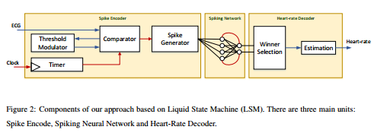

（1）using spiking neural networks, which can be implemented on energy efficient neuromorphic hardware;
(2) encoding analog ECG signal directly into spike trains, which are then used to excite the network of spiking neurons;
and (3) designing an unsupervised readout, facilitating learning from subject-specific ECG to estimate heartrate.

• A Python module to convert ECG to spikes.
• The core CARLsim simulator (in C++) implementing the Liquid.
• A Python readout implementing unsupervised heart-rate estimation.

Rate-based coding encodes information as number of spikes within an encoding window without considering the temporal characteristics of the signal. Rate-based encoding has been successfully applied to spatial classification tasks such as handwritten digit recognition

Temporal encoding has been successfully applied for time-series processing such as speech processing and EEG-based brain-machine interface

第一部分：encoding
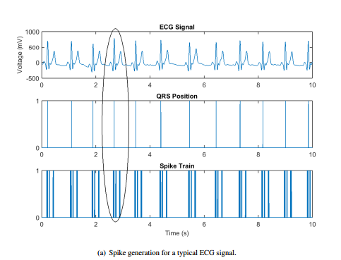
输入：input ECG signal

the Spike Encoding Circuit
using a combination of threshold modulators, voltage comparator, spike generator and a timer.
ECG signal is rising, ECG signal is falling and ECG signal is stable within a time window Delta.

• Threshold updates are performed to track the ECG signal in the upward or downward directions.
• No spikes are generated when the ECG signal is falling. This is a design choice
we use in this work as the spatio-temporal characteristics of the QRS can be
captured using the rising part of the voltage waveform.
• No spikes are generated if the ECG signal is stable.

输出：inter-spike intervals

第二部分：Spiking Neurons-Based Liquid
输入：inter-spike intervals
结构设计：
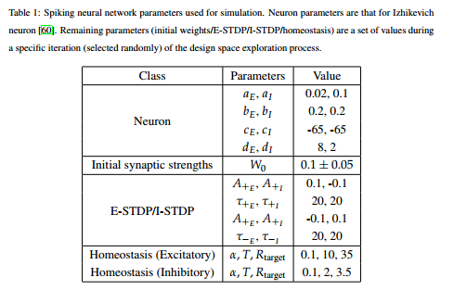
three layers – input, recurrent and output.

input：inter-spike intervals

recurrent：N = NE + NI ；NI = 0.25 · NE ；
excitatory neurons of the second layer can connect to any neurons
the inhibitory neurons are only connected to other excitatory neurons
excitatory to excitatory neurons have connection probabilities of 0.01; excitatory to inhibitory and inhibitory to excitatory neurons have connection probabilities of 0.1
Initial synaptic strengths W0 are reported in Table 1. Changes in synaptic strength are bounded between 0 and 10 × W0. Synaptic connection delays are selected randomly between 1ms and 2ms.
Learning using STDP and Homeostatic Plasticity
We have performed exploration with different number of excitatory and inhibitory neurons. Based on these explorations, the spiking network in our approach is built with 64 excitatory and 16 inhibitory neurons.

the output neurons reside inside the readout.
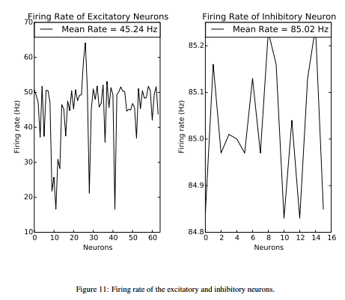
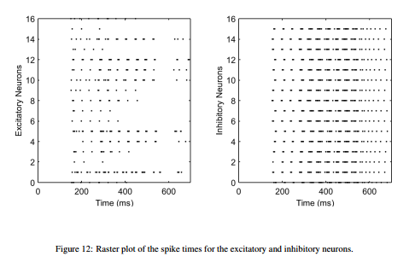

第三部分：Probabilistic Heart-rate Decoder as LSM Readout
We start our formulation by defining two intervals – the spike integrate interval (SI) and the heart-rate inference interval (HI). Spike responses from a neuron are integrated (i.e., counted) in every SI interval. In the remainder of this work, the term spike response is used to denote the spike count of a neuron in a SI interval, which is the smallest unit of time for our purpose.

The FCM algorithm minimizes the generalized least square error
Jm(ffi, c; Y) =ns-1 ∑i=0 nc-1 ∑j=0 (dij)m(yi - cj)T · A · (yi - cj)

Dimensionality Reduction And Cluster Center Selection

Fuzzy c-Means Outcome to Discrete Heart-rate Probability Distribution heart-rate = ns-1 ∑i=0 argmax(1 - di), di

